CS 255 Business Requirements Document Template

Complete this template by replacing the bracketed text with the relevant information.

This template lays out all the different sections that you need to complete for Project One. Each section has guiding questions to prompt your thinking. These questions are meant to guide your initial responses to each area. You are encouraged to go beyond these questions using what you have learned in your readings. You will need to continually reference the interview transcript as you work to make sure that you are addressing your client’s needs. There is no required length for the final document. Instead, the goal is to complete each section based on your client’s needs.

Tip: You should respond in a bulleted list for each section. This will make your thoughts easier to reference when you move into the design phase for Project Two. One starter bullet has been provided for you in each section, but you will need to add more.

System Components and Design

Purpose
What is the purpose of this project? Who is the client and what do they want their system to be able to do?
• Design and implement the DriverPass system so students can prepare for DMV exams with online practice tests, online course content, and optional on-the-road training.
• Provide secure, role-based access for DriverPass staff and customers (owner/management, IT admin, secretary, drivers/instructors, and students).
• Centralize scheduling, student records, training content, and reporting in a cloud-hosted system accessible from any computer or mobile device.

System Background
What does DriverPass want the system to do? What is the problem they want to fix? What are the different components needed for this system?
• DriverPass wants to reduce DMV test failures by giving students better tools than studying old tests: practice exams, training content, and scheduled behind-the-wheel sessions.
• The system must support online practice tests and (for some packages) online class content and materials.
• The system must support reservations for 2-hour driving lessons, including scheduling, canceling, and modifying appointments.
• The system must track lesson assignments (student, driver, car, date/time) and maintain driver notes/comments for each lesson.
• The system must support multiple user roles and permissions (IT admin can manage accounts and access).
• The system must provide reporting and downloads (e.g., exportable data for use in Excel).
• The system must support audit tracking of key actions (who created/changed/canceled reservations).
• The system should stay current with DMV rules/questions via a DMV update connection and notifications.

Objectives and Goals
What should this system be able to do when it is completed? What measurable tasks need to be included in the system design to achieve this?
• Allow customers to register, select a training package, and maintain a profile (name, address, phone, state, pickup/drop-off location).
• Provide online practice exams and display test progress (test name, time taken, score, and status: not taken, in progress, failed, passed).
• Allow customers and staff to schedule, modify, and cancel 2-hour driving lessons; prevent conflicts and overbooking.
• Assign a driver and a car to each scheduled lesson and allow staff to manage car/driver availability.
• Allow drivers to view their schedules and enter lesson notes/comments tied to the lesson date and time.
• Provide administrative reporting (reservation activity/audit, schedules, customer progress) and allow reports to be printed/downloaded (including Excel-friendly formats).
• Provide IT administration functions to reset passwords, deactivate accounts, and enforce role-based permissions.
• Notify administrators when DMV content/rules/questions are updated and support keeping practice tests current.

Requirements

Nonfunctional Requirements
In this section, you will detail the different nonfunctional requirements for the DriverPass system. You will need to think about the different things that the system needs to function properly.

Performance Requirements
What environments (web-based, application, etc.) does this system need to run in? How fast should the system run? How often should the system be updated?
• The system shall be a web-based application hosted in the cloud and accessible from desktop and mobile browsers.
• The system shall support normal usage with responsive page loads and near-real-time updates when users create/modify/cancel reservations while online.
• The system shall maintain high availability appropriate for a customer-facing service (with planned maintenance windows).
• The system shall support periodic updates to practice-test content and training materials as DMV rules change.

Platform Constraints
What platforms (Windows, Unix, etc.) should the system run on? Does the back end require any tools, such as a database, to support this application?
• The system shall support modern browsers on Windows and macOS desktops/laptops and iOS/Android mobile devices.
• The system shall use a centralized, cloud-hosted database to prevent duplicate/conflicting records (no offline edits).
• The system shall store operational data (users, packages, reservations, cars, drivers, test results, notes) in a relational database.
• The system shall integrate with a payment processor to handle credit card transactions securely (avoid storing sensitive card data directly in the system).
• If available, the system shall integrate with a DMV data source (API/feed) to receive updates and trigger notifications.

Accuracy and Precision
How will you distinguish between different users? Is the input case-sensitive? When should the system inform the admin of a problem?
• The system shall uniquely identify each user account and record creator/modifier (user ID, timestamp) for auditability.
• The system shall validate user input (required fields, correct formats for phone/state, and valid date/time selections).
• The system shall schedule lessons in 2-hour blocks and prevent double-booking of a driver or car for the same time.
• The system shall default the drop-off location to match the pickup location unless the user explicitly changes it.
• The system shall alert administrators and/or display errors when conflicts, failed updates, or invalid data are detected.

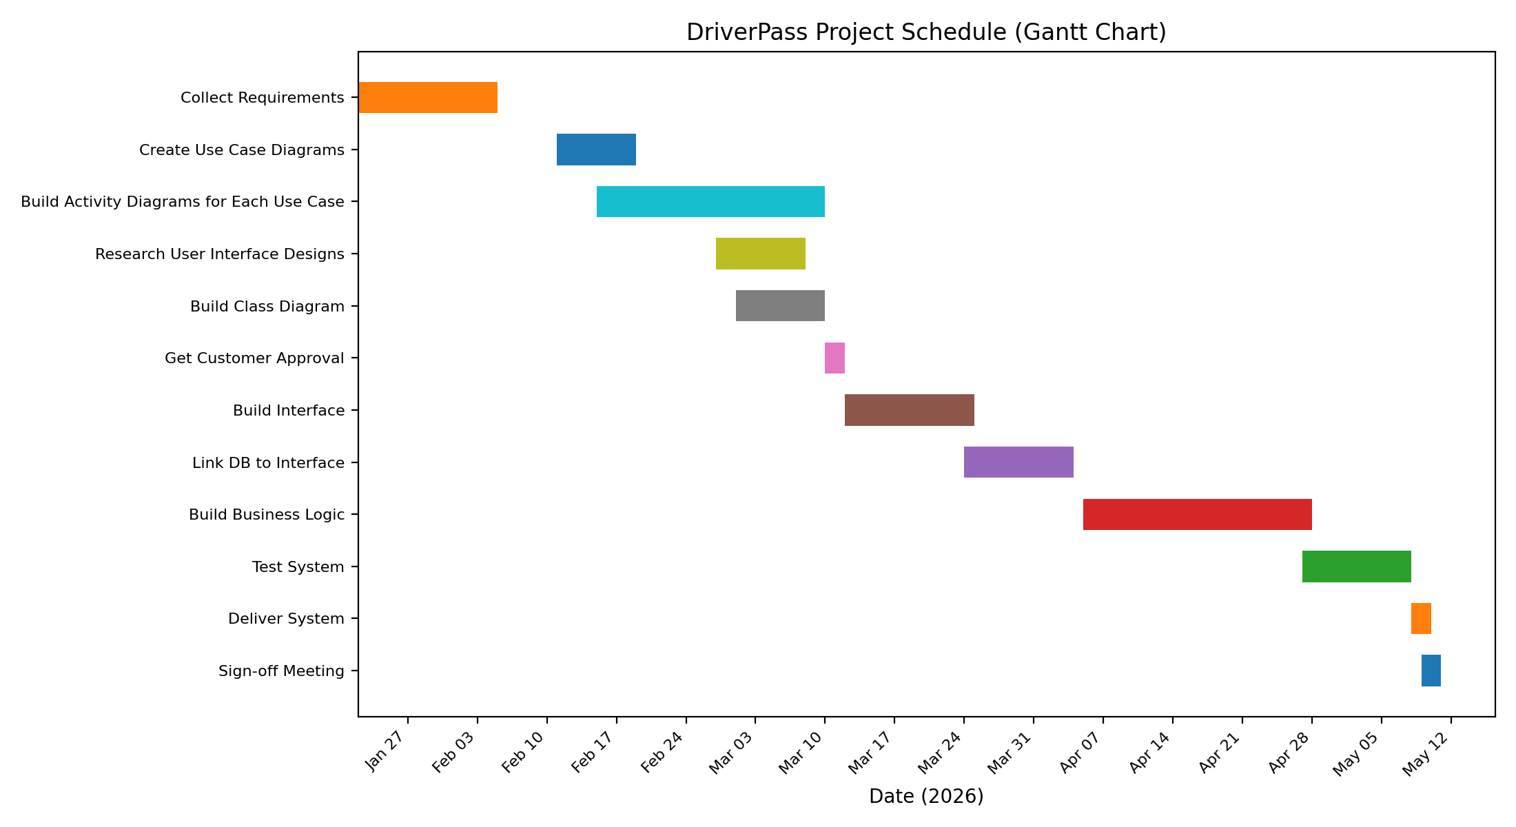
Can you make changes to the user (add/remove/modify) without changing code? How will the system adapt to platform updates? What type of access does the IT admin need?
• The system shall allow the IT administrator to add, deactivate, and manage user accounts and roles without code changes.
• The system shall allow management to disable a package so new customers cannot register for it.
• The system design should be modular so new packages and features can be added in future releases with developer support.
• The system shall support adding/removing cars and drivers through administrative configuration as the business grows.

Security
What is required for the user to log in? How can you secure the connection or the data exchange between the client and the server? What should happen to the account if there is a “brute force” hacking attempt? What happens if the user forgets their password?
• The system shall require users to authenticate (username/email and password) before accessing protected features.
• The system shall provide an automated password reset flow for customers who forget their passwords.
• The system shall use role-based access control so each role only sees the pages and actions they are permitted to use.
• The system shall protect data in transit with HTTPS/TLS and protect stored data with appropriate encryption and access controls.
• The system shall log critical actions (reservation create/modify/cancel, account changes) including who performed the action and when.
• The system shall implement protections against brute-force login attempts (rate limiting and/or temporary lockout).

Functional Requirements
Using the information from the scenario, think about the different functions the system needs to provide. Each of your bullets should start with “The system shall . . .” For example, one functional requirement might be, “The system shall validate user credentials when logging in.”
• The system shall allow customers to create an account and maintain their profile information.
• The system shall allow customers to purchase/register for one of the available training packages.
• The system shall provide online practice tests and store each attempt's score, time taken, and status.
• The system shall display a customer progress view showing tests taken, in progress, and completed results.
• The system shall allow customers to schedule, modify, and cancel 2-hour driving lessons online.
• The system shall allow the secretary to schedule, modify, and cancel driving lessons on behalf of customers.
• The system shall assign and track the driver and car associated with each scheduled lesson and prevent scheduling conflicts.
• The system shall allow drivers to enter lesson notes/comments linked to the lesson time window.
• The system shall maintain an audit trail for reservation-related actions (created, canceled, last modified) and support printing an activity report.
• The system shall allow authorized staff to generate and download reports and export selected data in an Excel-compatible format.
• The system shall allow the IT administrator to reset passwords, deactivate accounts, and manage role permissions.
• The system shall notify appropriate staff when DMV rules/policies/questions are updated and support updating practice-test content.

User Interface
What are the needs of the interface? Who are the different users for this interface? What will each user need to be able to do through the interface? How will the user interact with the interface (mobile, browser, etc.)?
• The system shall provide a responsive web interface usable on desktop and mobile devices.
• The system shall provide role-specific views/dashboards for customers, secretary, drivers, management, and IT administration.
• The customer interface shall include: registration/profile forms, package details, practice tests, and scheduling (make/modify/cancel appointments).
• The customer interface shall display test progress with fields such as test name, time taken, score, and status (not taken/in progress/failed/passed).
• The driver interface shall display upcoming lessons and provide a driver-notes entry table tied to lesson start/end times.
• The secretary interface shall provide customer lookup and an appointment scheduling workflow.
• Administrative interfaces shall support report generation, printing/downloading, and package enable/disable controls.
• The system shall provide a 'Contact Us' page and a way for staff to contact customers when needed.

Assumptions
What things were not specifically addressed in your design above? What assumptions are you making in your design about the users or the technology they have?
• Customers will have reliable internet access for scheduling, taking tests, and updating account information; offline access is limited to viewing downloaded reports.
• DriverPass will use a third-party payment processor; the system will store only transaction references rather than raw credit card security codes.
• DMV updates will be available via an API/feed or similar mechanism; if not available, DriverPass staff will manually update test content.
• Each driving lesson is a fixed 2-hour session, and cars/drivers are scheduled as shared resources.
• Drivers and staff will have accounts and access to the system during business operations.

Limitations
Any system you build will naturally have limitations. What limitations do you see in your system design? What limitations do you have as far as resources, time, budget, or technology?
• Users cannot modify or update records while offline; offline mode is read-only to avoid conflicting data versions.
• Package customization beyond enabling/disabling existing packages is out of scope for the initial release (future enhancement).
• Integration with the DMV (rules/questions updates) depends on external availability and may require manual workarounds.
• Project scope and delivery are constrained by the timeline and staffing described in the project schedule.
• The initial solution is designed as a web application; a native mobile app is not included in the initial release.

Gantt Chart
Please include a screenshot of the GANTT chart that you created with Lucidchart. Be sure to check that it meets the plan described by the characters in the interview.



